Assignment #3
Area Under a Curve and Handling Errors

(75 pts) We already have a program that finds the area of a rectangle and trapezoid. Now, we are going to modify that program to use the area of rectangles and/or trapezoids to find the area under a curve. We take the integral of a function to find the area under a curve, but how does a computer evaluate an integral? Is there an integrate function? Is there an integration symbol?

Objectives:
Analyze the different methods, rectangle vs. trapezoid methods, for solving integration problems. Write a program to calculate the area under a function using both the rectangle and trapezoid methods. Gain experience writing a short program, which uses selection, repetition, and error handling.

Background/Example:
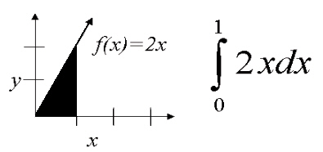
Basic Numerical Methods (Rectangle vs. Trapezoid):
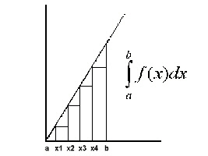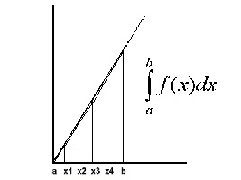

n = number of rectangles and/or trapezoids
a = beginning x value
b = ending x value
w = width of each rectangle/trapezoid, (b-a)/n
f(x) = height of rectangle
(f(x1)+f(x2))/2 = height of trapezoid
Area = width*height
Integration Program Definition:
Your program should determine the area under the function, f(x)=2x², bounded by any interval on the x-axis. The area calculated will be determined by the user's choice of method to use to calculate the integral, and it is possible for the user to choose to see the area calculated by both methods.
- If the user chooses to see the area calculated by both methods, each method should receive their own number of rectangles or trapezoids.
- Your program should continue running until the user no longer wants to calculate the area under a curve.
Program Input:
- Starting and ending points for the area
- Method(s) for calculating the area, i.e. rect, trap, both
- Number of rectangles and/or trapezoids to use
Program Output:
- The function being evaluated
- Starting and ending points for the integral
- Number of rectangles and/or trapezoids used
- The area calculated by the method(s)
Error Handling:
In the cases listed below, your program must print an error message and re-prompt the user for input:
- You must handle cases where the b value is larger than the a value.
- You must handle negative a and b values.
- You must handle situations where the user enters an erroneous menu selection for the calculation to perform.
- You must handle situations where the user enters an invalid option for the continue value.
- You must handle situations where the user enters invalid input for the a, b, and n values, such as a character rather than a number, 0 for n, etc.

(10 pts) In your implementation, make sure that you include a program header in your program, in addition to proper indentation/spacing and other comments!
/******************************************************
** Program: Integration.java
** Author: Your Name
** Date:
** Description:
** Input:
** Output:
******************************************************/

You are graded on having a header, proper comments, and readable code with indentation and vertical spacing that is CONSISTENT throughout your program. DO NOT align your entire program on the left side. This will cause you to automatically lose the full 10 points. In addition, do not forget your program header!!!

(15 pts) You are required to turn in a written document (as a pdf) addressing Polya’s steps to solving a problem with step 3 being the C code you write to carry out/implement your plan. With this said, your written document must include these three sections:

Understanding the Problem
In your own words, explain what YOU think the problem is asking you to do. In this section, document your uncertainties about the problem and anything else that you feel was unclear or vague. This is to ensure that YOUR understanding matches MY understanding of the problemJ

Devising a Plan/Design
At a minimum, provide an algorithm/pseudo code you designed to help solve the problem. In addition, include pictures/flow charts you used to help you devise your plan, as well as any other design decisions you made such as how to manage your time, how to decompose the problem, where to start first, etc. You can scan any handwritten work and attach it to the document as needed.

Looking Back/Self-Reflection
Report any checking/self-reflection you did while solving the problem. For instance, how did you make sense of the output from the implementation? This includes things such as using a calculator to make sure the output is correct, testing to make sure your code executes correctly and behaves the way you expect under specific circumstances, using external sources of information such as the internet to make sense of the results, etc. Also, include a statement about what you learned from the assignment.

